| **Solid State Drive** | | **Hard Disk Drive** | | |
| --- | --- | --- | --- | --- |
| **General Purpose – SSD (gp2)** | **Provision IOPS**  **(io1)** | **Throughput Optimized HDD (st1)**  **Cannot be use as root volume.** | **Cold HDD (sc1)**  **Cannot be use as root volume.** | **Magnetic EBS (HDD) (standard)** |
| * Common workload * System boot volume * Transactional workload, * Virtual desktop * Low latency interactive app, * Small databases, * DEV/Test environments, | * Mission Critical application * I/O intensive, * SQL and No-SQL databases. | * Ideal for streaming workload required fast consistent throughput at lower cost. * Big Data Application * For DB warehouse * For Log processing * Cannot be use as root-volume. | * Ideal for throughput-oriented storage for large volume of data that is infrequently access. * Ideal for scenarios where cost is a major factor. | * Low cost drive * Use for transactional workloads where performance is not dependent on the IOPS. * Use for infrequently access data. * Can be used as a root volume. |
| Sizes 1TiB – 16 TiB | Sizes 4TiB – 16 TiB | 500 GiB to 16TiB | 500 GiB to 16TiB | Size 1GiB to 1TiB |
| Max Throughput  160 MB/s | Max Throughput  500 MB/s | Max Throughput  500 MB/s | Max Throughput  250 MB/s. | Max Throughput  100 MB/s. |
| Max IOPS 10,000 | Max IOPS 32,000 | Max IOPS 500 | Max IOPS 250 | Max IOPS 200 |

* When need to add more compute - autoscaling: SCALE OUT.
* When need to reduce compute - autoscaling: SCALE IN.

|  |  |  |  |  |  |  |
| --- | --- | --- | --- | --- | --- | --- |
| **Real time storage class** | | | | |  | **Archival Storage** |
|  | **Standard** | **S3-IA** | **S3-Sigle Zone - IA** | **S3-Reduce Redundancy Storage** | **S3-Intelligent Tiering** | **Glacier** |
| Sustainability | Design to sustain data loss in two facility. | Design to sustain data loss more than 1 facility. | Design to sustain data loss in 1 facility. | Design to sustain data loss in 1 facility. |  | Store within a three physical availability zone within a same AWS region. |
| Availability | 99.99% | **99.90%** | **99%** | 99.99% | 99.99% | NO SLA |
| Durability | 99.999999999  **9 9’s** | 99.999999999 **9 9’s** | 99.999999999 **9 9’s** | **99.99%** | 99.999999999 **9 9’s** | 99.999999999 **9 9’s** |
| Minimum Size | 0 KB – 5TB | Greater than 128 KB |  |  | 128KB | 1 Byte – 40TB |
| Usages | critical data | Old less frequently use data. | Non-critical data | Non-critical data / temp for downloading archive data | Use for those objects whose access patter are complex to identify. | Archiving data |
| Retention Period | Minimum of 30 days charge is applicable. | Minimum of 30 days charge is applicable. | Minimum of 30 days charge is applicable. |  | Minimum 30 days charges are applicable | Minimum of 90 days charge is applicable. |

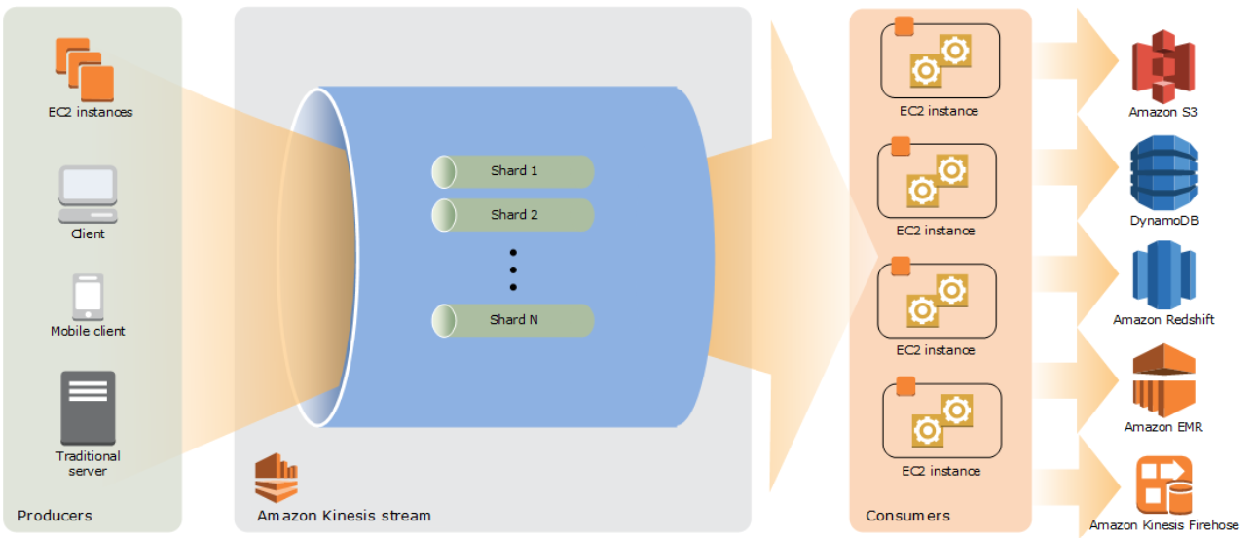

|  |  |  |
| --- | --- | --- |
| AWS Microsoft Active Directory Service | AD Connect | Simple AD |
| Fully functional managed Microsoft Active directory | Used for connecting on-premises Active Directory with AWS | This is a small SAMBA4 base active directory mostly used for manging small user group |
| >=5000 user  <= 5000 users – standard edition.  >= 5000 users – enterprise edition. | 500-5000  SMALL – 500 users  LARGE – 500 - 5000 users | 500-5000  SMALL – 500 users  LARGE – 500 - 5000 users |

|  |  |  |  |
| --- | --- | --- | --- |
| Storage Gateway | | | |
| File Gateway | Volume Gateway | | Tape Gateway |
|  | Volume Cache Gateway | Volume Store Gateway |  |